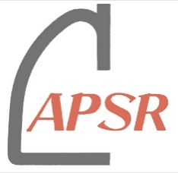

For APSR Multi-Society Research Project

Application form
Please submit this form to research@theapsr.org no later than 30 June 2024.

Applicant
Name:
Country / Region:
Affiliation:
Email address:
APSR Membership:
*Please write your en bloc society name or individual membership no.

Application Date
dd / mm / 20yy

Fund request
US$

Project title

Project term
(In principle, the duration of the project shall be two years)
dd / mm / 20yy ~ dd / mm / 20yy

Project team members
(The project team are all APSR assembly members from two or more en bloc societies and from two or more countries /regions in the Asia-Pacific region and there should be at least 4 members in the team)
Principal investigator
Name:
Country / Region:
Affiliation:
Email address:
APSR Membership:
*Please write your en bloc society name or individual membership no.
Co-Investigator
Name:
Country / Region:
Affiliation:
Email address:
APSR Membership:
*Please write your en bloc society name or individual membership no.
Co-Investigator
Name:
Country / Region:
Affiliation:
Email address:
APSR Membership:
*Please write your en bloc society name or individual membership no.
Co-Investigator
Name:
Country / Region:
Affiliation:
Email address:
APSR Membership:
*Please write your en bloc society name or individual membership no.

Add more Co-investigator(s) if necessary

Project summary

Purpose and Necessity
(including the impact/relevance to the Asia-Pacific region)

Background
(including the previous studies and preliminary data)

Methods
(including the organization of the research team and the background of the members)

Expectation and application of the results
(including the impact of the research on the current understanding)

References

Timeline

Budget plan
(The fund will be transferred to project team members’ institution(s), not a personal account. Any administration charge by the institution for processing the fund is to be included in the budget plan)

Applicant’s signature *You can paste an image of your signature.

Date:
Name:

